**TIME BASED ATTENDANCE MANAGEMENT SYSTEM BASED ON FACE RECOGNITION**

|  |  |
| --- | --- |
| **CONTENT** | **PAGE NO** |
| **Abstract** |  |
| **1.INTRODUCTION** |  |
| 1.1 Motivation |  |
| 1.2 Problem Statement |  |
| 1.3 Objective of the Project |  |
| 1.4 Scope |  |
| 1.5 Project Introduction |  |
| **2.LTERATURE SURVEY** |  |
| 2.1 Related Work |  |
| **3. SYSTEM ANALYSIS** |  |
| 3.1 Existing System |  |
| 3.2 Disadvantages |  |
| 3.3 Proposed System |  |
| 3.4 Advantages |  |
| 3.5 work Flow of Proposed system |  |
| **4. REQUIREMENT ANALYSIS** |  |
| 4.1Function and non-functional requirements |  |
| 4.2 Hardware Requirements |  |
| 4.3 Software Requirements |  |
| 4.4 Architecture |  |
| **5. SYSTEM DESIGN** |  |
| 5.1 Introduction of Input design |  |
| 5.2 UML Diagram(class, use case, sequence, collaborative, deployment, activity, ER diagram and Component diagram) |  |
| 5.3 Data Flow Diagram |  |
| **6. IMPLEMENTATION AND RESULTS** |  |
| 6.1 Modules |  |
| 6.2 Output Screens |  |
| 1. **SYSTEM STUDY AND TESTING** |  |
| 7.1 Feasibility study |  |
| 7.2 Types of test & Test Cases |  |
| **8. CONCLUSION** |  |
| **9. FUTURE ENHANCEMENT** |  |
| **10. REFERENCES** |  |

**ABSTRACT**

**Abstract**

This paper introduces a Time-Based Attendance Management System that aims to streamline and modernize the traditional manual attendance tracking method, which is both time-consuming and challenging to maintain. The proposed system leverages advanced biometric technology, particularly Deep Learning (DL) based Face Recognition algorithms. Human faces serve as the primary dataset for training, employing the LBPH Face Recognizer. The user interface is developed through the Flask framework, providing a user-friendly web page. Notably, as an enhancement to this system, it offers the capability to store attendance data in a database, including timestamps. Furthermore, an innovative feature has been integrated to notify parents about attendance, marks, and behavior of their children using the Fast to SMS website. This enhancement not only enhances efficiency but also strengthens the communication between educational institutions and parents, fostering a more informed and engaged educational environment.

**Keywords**: Attendance Management, Computer Vision, Deep Learning, Human Face Images, sending SMS.

**INTRODUCTION**

**1.1 MOTIVATION**

The motivation behind this project lies in revolutionizing attendance management within educational institutions. By employing cutting-edge Deep Learning technology for face recognition, the system ensures accuracy and efficiency in tracking attendance. This not only streamlines administrative tasks but also promotes a culture of punctuality among students. Integrating real-time notifications through Fast to SMS fosters seamless communication between schools and parents, fostering greater involvement in their child's education. Ultimately, this initiative seeks to enhance student monitoring, improve parental engagement, and contribute to the overall efficiency and effectiveness of the educational process.

**1.2 PROBLEM STATEMENT**

Traditional manual attendance management in educational institutions is time-consuming, error-prone, and challenging to maintain, adversely affecting class efficiency and data accuracy. This project addresses these issues by developing a Time-Based Attendance Management System that utilizes Deep Learning-based Face Recognition to automate attendance tracking accurately. The main challenge is creating a reliable facial recognition system capable of efficiently identifying and recording student attendance, which will be securely stored in a database. Additionally, the system will send automated messages to parents via the Fast to SMS website, enhancing communication between schools and parents to improve student management and engagement.

**1.3 OBJECTIVE OF THE PROJECT**

The objectives of this project can be summarized in five key points:

1. Develop a reliable and accurate Deep Learning-based Face Recognition system to automate the attendance tracking process in educational institutions.

2. Create a secure database infrastructure for storing attendance data, including timestamps and relevant student information.

3. Implement a user-friendly web-based interface using the Flask framework for easy access and management of attendance records.

4. Integrate a messaging feature through the Fast to SMS website to automatically notify parents about their children's attendance, marks, and behavior.

5. Enhance efficiency, reduce errors, and improve communication between educational institutions and parents, fostering a more informed and engaged educational environment.

**1.4 SCOPE:**

The scope of this project encompasses the design and implementation of a Time-Based Attendance Management System for educational institutions. It involves the development of a robust Deep Learning-based Face Recognition system for automated and accurate attendance tracking. The system will store attendance data securely in a database for future analysis. Additionally, it will integrate a feature to send automated notifications to parents through the Fast to SMS website, providing real-time updates on attendance, marks, and behavior. This project aims to streamline attendance management, enhance communication, and contribute to efficient student monitoring and parental involvement in education.

**1.5 PROJECT INTRODUCTION**

In today's rapidly evolving technological landscape, the need for efficiency and accuracy in educational institutions has become increasingly apparent. One area where traditional methods have proven to be time-consuming and error-prone is attendance management. Conventional approaches often involve manual attendance tracking through paper registers or roll calls, leading to inefficiencies, inaccuracies, and delayed reporting. These limitations not only burden educators but also compromise the overall educational experience and the security of attendance records. Recognizing these challenges, this paper introduces the Time-Based Attendance Management System, an innovative solution aimed at revolutionizing attendance management within educational institutions.

The project's problem statement revolves around the pressing need to modernize attendance management in educational institutions. Manual methods are not only labor-intensive but also lack real-time tracking capabilities for student attendance. Beyond merely taking attendance, these methods hinder the effective monitoring of student performance and behavior. Additionally, they limit parental involvement due to a lack of timely information.

The primary objectives of this project encompass the development of a reliable Deep Learning-based Face Recognition system for automated attendance tracking, the creation of a secure database infrastructure to store attendance data, the implementation of a user-friendly web interface using the Flask framework, the integration of a messaging feature through the Fast to SMS website for automated parent notifications, and the enhancement of efficiency and communication within educational institutions.

The project's scope includes designing, developing, and implementing the Time-Based Attendance Management System tailored to the specific needs of educational institutions. This system seeks to replace manual attendance tracking with an automated solution that leverages cutting-edge technology, ensuring both accuracy and data security. By creating a user-friendly web interface and automating parent notifications, the project aims to streamline attendance management, reduce administrative burdens, and foster parental involvement. Overall, the system is poised to optimize efficiency, accuracy, and communication within educational institutions, contributing to a more informed and engaged educational ecosystem.

This project holds significant promise in improving the educational experience for educators, students, and parents alike. Through the automation of attendance tracking and the provision of real-time updates to parents, it addresses the limitations of manual methods, enhancing efficiency, accuracy, and communication within educational institutions. In the subsequent sections, we will delve into the technical aspects of the system's development, including the Deep Learning-based Face Recognition algorithm, database infrastructure, web interface, and integration with the Fast to SMS website for automated parent notifications, demonstrating the feasibility and effectiveness of our proposed solution.

**2. LITERATURE SURVEY**

**[1] Naveed Khan Balcoh, M. HaroonYousaf, Waqar Ahma and M. Iram Baig:** Students attendance in the classroom is very important task and if taken manually wastes a lot of time. There are many automatic methods available for this purpose i.e. Biometric attendance. All these methods also waste time because students have to make a queue to touch their thumb on the scanning device. This work describes the efficient algorithm that automatically marks the attendance without human intervention. This attendance is recorded by using a camera attached in front of classroom that is continuously capturing images of students, detect the faces in images and compare the detected faces with the database and mark the attendance.

**Summary:** Students attendance in the classroom is very important task and if taken manually wastes a lot of time. There are many automatic methods available for this purpose i.e. Biometric attendance. All these methods also waste time because students have to make a queue to touch their thumb on the scanning device. This work describes the efficient algorithm that automatically marks the attendance without human intervention.

**[2] NirmalayaKar, MrinalKanti Debbarma, Ashim Saha, and Dwijen RudraPal:** Authentication is a significant issue in system control in computer based communication. Human face recognition is an important branch of biometric verification and has been widely used in many applications, such as video monitor system, human-computer interaction, and door control system and network security. This describes a method for Student’s Attendance System which will integrate with the face recognition technology using Personal Component Analysis (PCA) algorithm. The system will record the attendance of the students in class room environment automatically and it will provide the facilities to the faculty to access the information of the students easily by maintaining a log for clock-in and clock-out time.

**Summary:** This describes a method for Student’s Attendance System which will integrate with the face recognition technology using Personal Component Analysis (PCA) algorithm. The system will record the attendance of the students in class room environment automatically and it will provide the facilities to the faculty to access the information of the students easily by maintaining a log for clock-in and clock-out time.

**[3] O. Shoewn:** In this paper, the development of an attendance management system using biometrics is proposed. Managing student attendance during lecture periods has become a difficult challenge. The ability to compute the attendance percentage becomes a major task as manual computation produces errors, and also wastes a lot of time. For the stated reason, an efficient attendance management system using biometrics is designed. This system takes attendance electronically with the help of a finger print device and the records of the attendance are stored in a database. Attendance is marked after student identification.

**Summary:** For student identification, a biometric (fingerprint) identification based system is used. This process however, eliminates the need for stationary materials and personnel for the keeping of records. Eighty candidates were used to test the system and success rate of 94% was recorded. The manual attendance system average execution time for eighty students was 17.83 seconds while it was 3.79 seconds for the automatic attendance management system using biometrics.

**[4] M. Turk and A. Pentland:** An approach to the detection and identification of human faces is presented, and a working, near-real-time face recognition system which tracks a subject's head and then recognizes the person by comparing characteristics of the face to those of known individuals is described. This approach treats face recognition as a two-dimensional recognition problem, taking advantage of the fact that faces are normally upright and thus may be described by a small set of 2-D characteristic views. Face images are projected onto a feature space ('face space') that best encodes the variation among known face images. The face space is defined by the 'Eigen faces', which are the eigenvectors of the set of faces; they do not necessarily correspond to isolated features such as eyes, ears, and noses. The framework provides the ability to learn to recognize new faces in an unsupervised manner.

**Summary:** This approach treats face recognition as a two-dimensional recognition problem, taking advantage of the fact that faces are normally upright and thus may be described by a small set of 2-D characteristic views. Face images are projected onto a feature space ('face space') that best encodes the variation among known face images. The face space is defined by the 'Eigen faces', which are the eigenvectors of the set of faces; they do not necessarily correspond to isolated features such as eyes, ears, and noses.

**[5] Rekha A. L, Chethan H. K**: The objective of this system is to present an automated system for human face recognition in a real time background for an organization to mark the attendance of their employees or student. So automated attendance using real time face recognition is a real world solution which comes with day to day activities of handling employees or student. The task is very difficult as the real time background subtraction in an image is still a challenge. In the past two decades, face detection and recognition has proven to be very interesting research field of image processing.

**Summary:** The work carried out describes an automated attendance system using video surveillance. The proposed algorithm is automatic and efficient in intelligent surveillance applications. Video surveillance is used to detect the object movement thereby the captured image undergoes face detection and recognition process and searches the student database and enters the attendance if it is valid in the list.

**3. SYSTEM ANALYSIS**

**3.1 Existing Method:**

The existing system for attendance management in educational institutions relies on manual methods, where educators manually mark and record students' attendance during each class. This manual process is time-consuming, prone to errors, and lacks real-time tracking capabilities. To address these challenges, our project introduces a modernized approach that leverages Face Recognition technology. By implementing Deep Learning-based Face Recognition, the system aims to automate the attendance tracking process. Students' faces are scanned, identified, and their attendance is recorded in real-time. This transition from the traditional manual system to automated Face Recognition offers a more efficient and accurate means of managing attendance, improving the overall educational experience.

**DISADVANTAGES**

Face recognition-based attendance tracking systems have disadvantages:

**1.Privacy Concerns:** These systems can raise privacy issues as they involve biometric data collection, which individuals may find invasive.

**2.Accuracy:** Accuracy may be compromised due to variations in lighting, facial expressions, or occlusions.

**3.Costly Implementation:** Setting up face recognition systems can be expensive due to the need for specialized hardware and software.

**4.Security Vulnerabilities:** Face recognition can be vulnerable to spoofing or hacking attempts.

**5.Ethical Concerns:** Concerns about consent and misuse of biometric data must be addressed.

**6.Dependency on Technology:** Technical failures or outages can disrupt attendance tracking.

**7.Cultural Sensitivity:** Different cultural norms may affect acceptance and usage.

**PROPOSED SYSTEM**

The proposed system aims to revolutionize attendance management in educational institutions by implementing Deep Learning-based Face Recognition for automated attendance tracking. This modernized approach eliminates the drawbacks of the manual system, offering efficiency and accuracy. Additionally, as an enhancement, the system will integrate with the Fast to SMS website, enabling automatic notifications to parents regarding their children's attendance, academic marks, and behavior. This feature fosters better communication between the institution and parents, enhancing parental involvement and ensuring that they stay informed about their child's educational progress. Overall, the proposed system combines cutting-edge technology with improved communication for a more efficient and engaged educational environment.

**ADVANTAGES**

Advantages of the Proposed Time-Based Attendance Management System:

1. Enhanced Accuracy: The Deep Learning-based Face Recognition system ensures precise attendance tracking, reducing the chances of errors in recording attendance data.

2. Real-time Monitoring: The system allows for real-time attendance updates, enabling educators to promptly address attendance-related issues and maintain class efficiency.

3. Improved Parental Engagement: Integration with the Fast to SMS website provides parents with timely notifications about attendance, marks, and behavior, fostering active parental involvement in their child's education.

4. Time Efficiency: Automation reduces the time spent on manual attendance-taking, allowing educators to allocate more time to instructional activities.

5. Data Security: The secure database infrastructure safeguards attendance records, ensuring the confidentiality and integrity of sensitive student data.

**3.5 Work Flow of Proposed System**

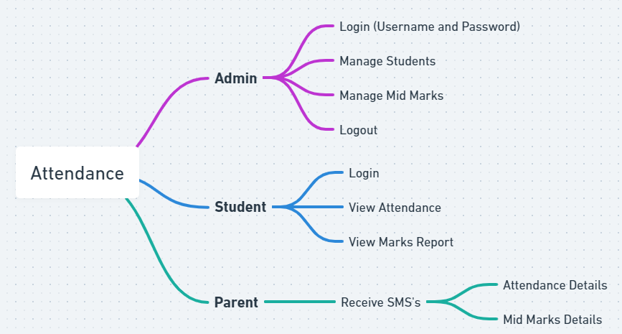

**4. REQUIREMENT ANALYSIS**

**4.1 Functional and non-functional requirements**

Requirement’s analysis is very critical process that enables the success of a system or software project to be assessed. Requirements are generally split into two types: Functional and non-functional requirements.

**Functional Requirements**: These are the requirements that the end user specifically demands as basic facilities that the system should offer. All these functionalities need to be necessarily incorporated into the system as a part of the contract. These are represented or stated in the form of input to be given to the system, the operation performed and the output expected. They are basically the requirements stated by the user which one can see directly in the final product, unlike the non-functional requirements.

Examples of functional requirements:

1. Authentication of user whenever he/she logs into the system
2. System shutdown in case of a cyber-attack
3. A verification email is sent to user whenever he/she register for the first time on some software system.

**Non-functional requirements**: These are basically the quality constraints that the system must satisfy according to the project contract. The priority or extent to which these factors are implemented varies from one project to other. They are also called non-behavioral requirements.  
They basically deal with issues like:

* Portability
* Security
* Maintainability
* Reliability
* Scalability
* Performance
* Reusability
* Flexibility

Examples of non-functional requirements:

1. Emails should be sent with a latency of no greater than 12 hours from such an activity.
2. The processing of each request should be done within 10 seconds
3. The site should load in 3 seconds whenever of simultaneous users are > 10000
   1. **Hardware Requirements**

# Processor - I3/Intel Processor

Hard Disk - 160GB

Key Board - Standard Windows Keyboard

Mouse - Two or Three Button Mouse

Monitor - SVGA

RAM - 8GB

* 1. **Software Requirements:**

Operating System : Windows 7/8/10

Server side Script : HTML, CSS, Bootstrap & JS

Programming Language : Python

Libraries : Flask, Pandas, Mysql.connector, Os, Smtplib, Numpy

IDE/Workbench : PyCharm

Technology : Python 3.6+

Server Deployment : Xampp Server

Database : MySQL

**SYSTEM DESIGN:**

## Input Design:

In an information system, input is the raw data that is processed to produce output. During the input design, the developers must consider the input devices such as PC, MICR, OMR, etc.

Therefore, the quality of system input determines the quality of system output. Well-designed input forms and screens have following properties −

* It should serve specific purpose effectively such as storing, recording, and retrieving the information.
* It ensures proper completion with accuracy.
* It should be easy to fill and straightforward.
* It should focus on user’s attention, consistency, and simplicity.
* All these objectives are obtained using the knowledge of basic design principles regarding −
  + What are the inputs needed for the system?
  + How end users respond to different elements of forms and screens.

### Objectives for Input Design:

The objectives of input design are −

* To design data entry and input procedures
* To reduce input volume
* To design source documents for data capture or devise other data capture methods
* To design input data records, data entry screens, user interface screens, etc.
* To use validation checks and develop effective input controls.

**Output Design:**

The design of output is the most important task of any system. During output design, developers identify the type of outputs needed, and consider the necessary output controls and prototype report layouts.

### Objectives of Output Design:

The objectives of input design are:

* To develop output design that serves the intended purpose and eliminates the production of unwanted output.
* To develop the output design that meets the end user’s requirements.
* To deliver the appropriate quantity of output.
* To form the output in appropriate format and direct it to the right person.
* To make the output available on time for making good decisions.
  1. **Architecture:**

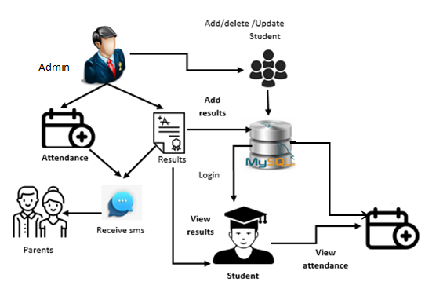

**SYSTEM DESIGN:**

## **Input Design:**

In an information system, input is the raw data that is processed to produce output. During the input design, the developers must consider the input devices such as PC, MICR, OMR, etc.

Therefore, the quality of system input determines the quality of system output. Well-designed input forms and screens have following properties −

* It should serve specific purpose effectively such as storing, recording, and retrieving the information.
* It ensures proper completion with accuracy.
* It should be easy to fill and straightforward.
* It should focus on user’s attention, consistency, and simplicity.
* All these objectives are obtained using the knowledge of basic design principles regarding
  + What are the inputs needed for the system?
  + How end users respond to different elements of forms and screens.

### Objectives for Input Design:

The objectives of input design are −

* To design data entry and input procedures
* To reduce input volume
* To design source documents for data capture or devise other data capture methods
* To design input data records, data entry screens, user interface screens, etc.
* To use validation checks and develop effective input controls.

**Output Design:**

The design of output is the most important task of any system. During output design, developers identify the type of outputs needed, and consider the necessary output controls and prototype report layouts.

### Objectives of Output Design:

The objectives of input design are:

* To develop output design that serves the intended purpose and eliminates the production of unwanted output.
* To develop the output design that meets the end user’s requirements.
* To deliver the appropriate quantity of output.
* To form the output in appropriate format and direct it to the right person.
* To make the output available on time for making good decisions.

**MODULES:**

**Enter Data:**

* Add the details like Roll number and Name and parent mobile number.
* After entering the details click on the image capture button.

**Data Gathering:**

* After clicking the capture button the web cam will be opened for taking images and it captures 200 frames, after completion of taking images web cam will be automatically closed.

**Training:**

* All captured images are saved in a "Training image" folder. The LBPH (Local Binary Patterns Histograms) Face Recognizer_create() function is utilized to recognize facial features for training purposes.

**Testing and considering the attendance**

* Whenever a student made a click on the button provided, a web cam will gets opened.
* The web cam has ability to capture the image of the particular students face and then the image is converted into greyscale and it undergoes for scaling
* The scaled image is converted into the form of vectors with the help of LBPH Face Recognizer_create
* Now the converted data will be helpful to predict the outcomes.
* There are 4 conditions to collect the attendance
* 1. Before 10AM – Early come 2. After 10AM – Late
* 3. Before 4PM – Early out 4. After 4PM- Normal out
* After checking the conditions data will be stored in database. And system automatically send a SMS to student parents through mobile regarding timings of attendance.

**ADMIN**

* Admin will add the marks
* Here we will send an sms to parents about the Marks and Behaviour of student by using the Fast to SMS website as an enhancement.

**STUDENT**

**Take Attendance**

* Student attendance will be captured through web cam which was installed and will be capturing continuously.
* Once after recognizing face of a student data will be stored in server and it will send a sms to student parent.
* Here student can select the options like take attendance button then only system can access the attendance. After that system stores the information into MYSQL database.

**View Attendance**

* After entering the roll number student can view their attendance details.

**SYSTEM DESIGN**

**UML Diagrams**

UML stands for Unified Modeling Language. UML is a standardized general-purpose modeling language in the field of object-oriented software engineering. The standard is managed, and was created by, the Object Management Group.

The goal is for UML to become a common language for creating models of object oriented computer software. In its current form UML is comprised of two major components: a Meta-model and a notation. In the future, some form of method or process may also be added to; or associated with, UML.

The Unified Modeling Language is a standard language for specifying, Visualization, Constructing and documenting the artifacts of software system, as well as for business modeling and other non-software systems.

The UML represents a collection of best engineering practices that have proven successful insists the modeling of large and complex systems.

The UML is a very important part of developing objects oriented software and the software development process. The UML uses mostly graphical notations to express the design of software projects.

**Goals:**

The Primary goals in the design of the UML are as follows:

1. Provide users a ready-to-use, expressive visual modeling Language so that they can develop and exchange meaningful models.
2. Provide extendibility and specialization mechanisms to extend the core concepts.
3. Be independent of particular programming languages and development process.
4. Provide a formal basis for understanding the modeling language.
5. Encourage the growth of OO tools market.
6. Support higher level development concepts such as collaborations, frameworks, patterns and components.
7. Integrate best practices.

**Use Case Diagram:**

A use case diagram in the Unified Modeling Language (UML) is a type of behavioral diagram defined by and created from a Use-case analysis. Its purpose is to present a graphical overview of the functionality provided by a system in terms of actors, their goals (represented as use cases), and any dependencies between those use cases. The main purpose of a use case diagram is to show what system functions are performed for which actor. Roles of the actors in the system can be depicted.

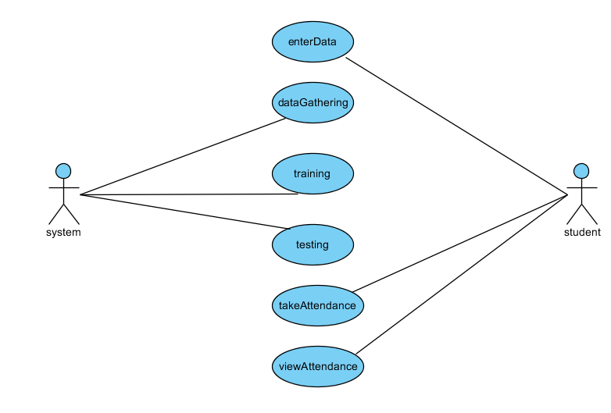

**Class Diagram:**

In software engineering, a class diagram in the Unified Modeling Language (UML) is a type of static structure diagram that describes the structure of a system by showing the system's classes, their attributes, operations (or methods), and the relationships among the classes. It explains which class contains information.

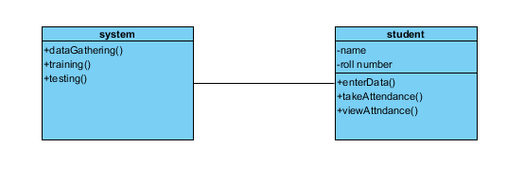

**Sequence Diagram:**

A sequence diagram in Unified Modeling Language (UML) is a kind of interaction diagram that shows how processes operate with one another and in what order. It is a construct of a Message Sequence Chart. Sequence diagrams are sometimes called event diagrams, event scenarios, and time diagrams.

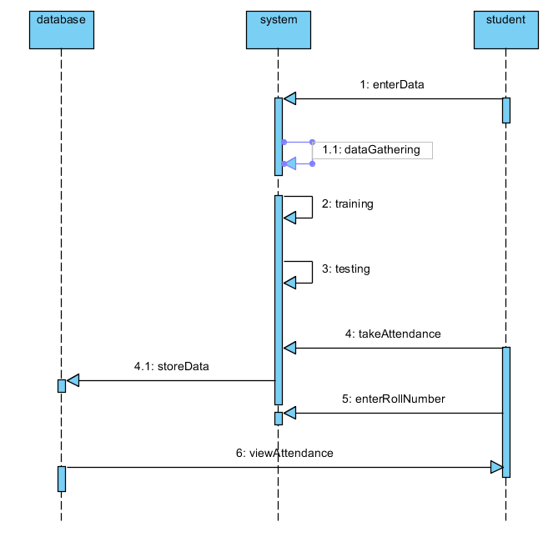

**Collaboration Diagram:**

In collaboration diagram the method call sequence is indicated by some numbering technique as shown below. The number indicates how the methods are called one after another. We have taken the same order management system to describe the collaboration diagram. The method calls are similar to that of a sequence diagram. But the difference is that the sequence diagram does not describe the object organization whereas the collaboration diagram shows the object organization.

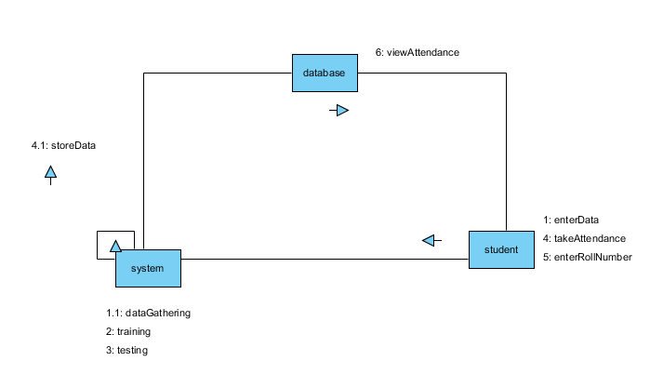

**Deployment diagram**

Deployment diagram represents the deployment view of a system. It is related to the component diagram. Because the components are deployed using the deployment diagrams. A deployment diagram consists of nodes. Nodes are nothing but physical hardware’s used to deploy the application.

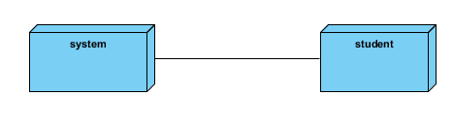

**Activity Diagram:**

Activity diagrams are graphical representations of workflows of stepwise activities and actions with support for choice, iteration and concurrency. In the Unified Modeling Language, activity diagrams can be used to describe the business and operational step-by-step workflows of components in a system. An activity diagram shows the overall flow of control.

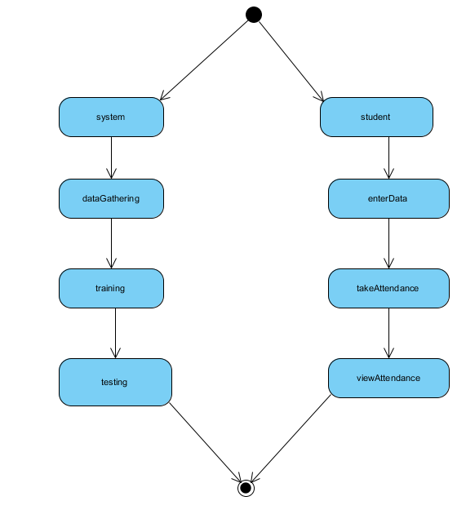

**Component diagram**:

A component diagram, also known as a UML component diagram, describes the organization and wiring of the physical **c**omponents in a system. Component diagrams are often drawn to help model implementation details and double-check that every aspect of the system's required functions is covered by planned development.

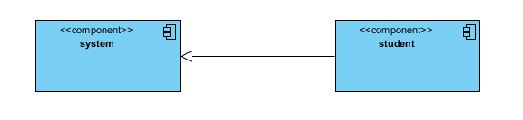

**ER Diagram:**

An Entity–relationship model (ER model) describes the structure of a database with the help of a diagram, which is known as Entity Relationship Diagram (ER Diagram). An ER model is a design or blueprint of a database that can later be implemented as a database. The main components of E-R model are: entity set and relationship set.

An ER diagram shows the relationship among entity sets. An entity set is a group of similar entities and these entities can have attributes. In terms of DBMS, an entity is a table or attribute of a table in database, so by showing relationship among tables and their attributes, ER diagram shows the complete logical structure of a database. Let’s have a look at a simple ER diagram to understand this concept.

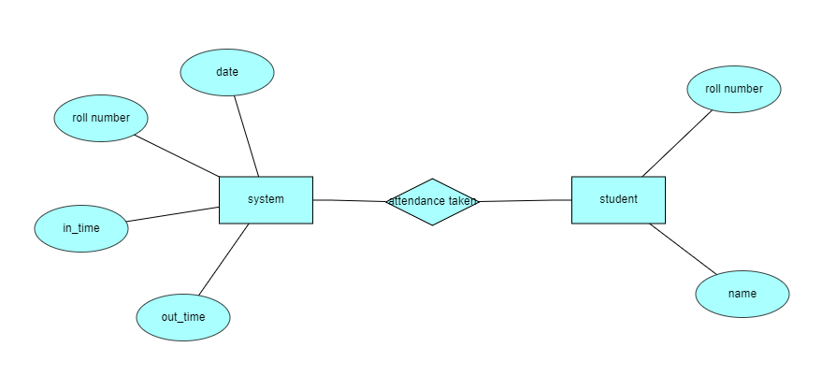

**DFD Diagram:**

A Data Flow Diagram (DFD) is a traditional way to visualize the information flows within a system. A neat and clear DFD can depict a good amount of the system requirements graphically. It can be manual, automated, or a combination of both. It shows how information enters and leaves the system, what changes the information and where information is stored. The purpose of a DFD is to show the scope and boundaries of a system as a whole. It may be used as a communications tool between a systems analyst and any person who plays a part in the system that acts as the starting point for redesigning a system.

**CONTEXT LEVEL DIAGRAM**

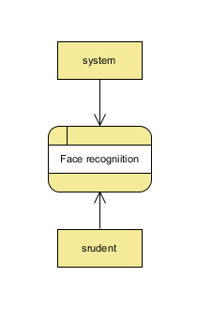

**LEVEL-1 DIAGRAM**

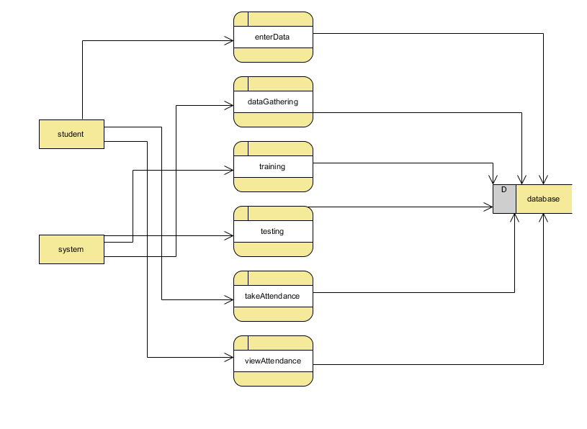

**LEVEL-2 DIAGRAM**

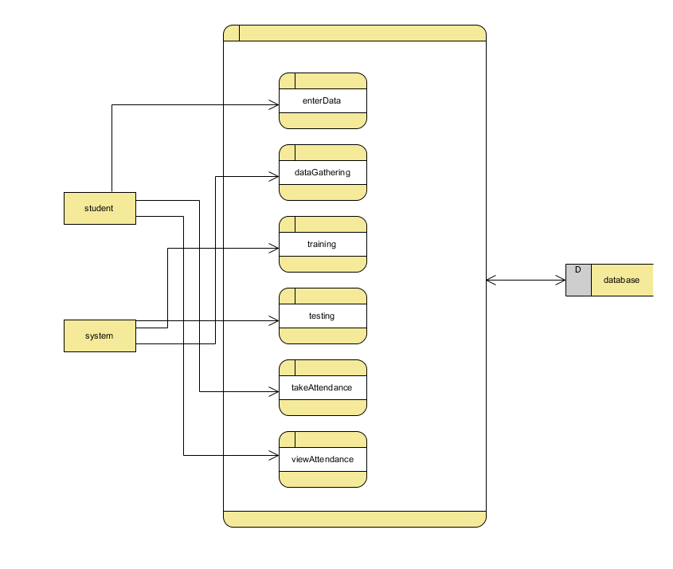

**6.1 IMPLEMENTATION:**

**Enter Data:**

* Add the details like Roll number and Name and parent mobile number.
* After entering the details click on the image capture button.

**Data Gathering:**

* After clicking the capture button the web cam will be opened for taking images and it captures 200 frames, after completion of taking images web cam will be automatically closed.

**Training:**

* All captured images are saved in a "Training image" folder. The LBPH (Local Binary Patterns Histograms) Face Recognizer_create() function is utilized to recognize facial features for training purposes.

**Testing and considering the attendance**

* Whenever a student made a click on the button provided, a web cam will gets opened.
* The web cam has ability to capture the image of the particular students face and then the image is converted into greyscale and it undergoes for scaling
* The scaled image is converted into the form of vectors with the help of LBPH Face Recognizer_create
* Now the converted data will be helpful to predict the outcomes.
* There are 4 conditions to collect the attendance
* 1. Before 10AM – Early come 2. After 10AM – Late
* 3. Before 4PM – Early out 4. After 4PM- Normal out
* After checking the conditions data will be stored in database. And system automatically send a SMS to student parents through mobile regarding timings of attendance.

**ADMIN**

* Admin will add the marks
* Here we will send an sms to parents about the Marks and Behaviour of student by using the Fast to SMS website as an enhancement.

**STUDENT**

**Take Attendance**

* Student attendance will be captured through web cam which was installed and will be capturing continuously.
* Once after recognizing face of a student data will be stored in server and it will send a sms to student parent.
* Here student can select the options like take attendance button then only system can access the attendance. After that system stores the information into MYSQL database.

**View Attendance**

* After entering the roll number student can view their attendance details.
* **6.2 Results:**

**Home Page:** Time based attendance management system based on face recognition Home page.

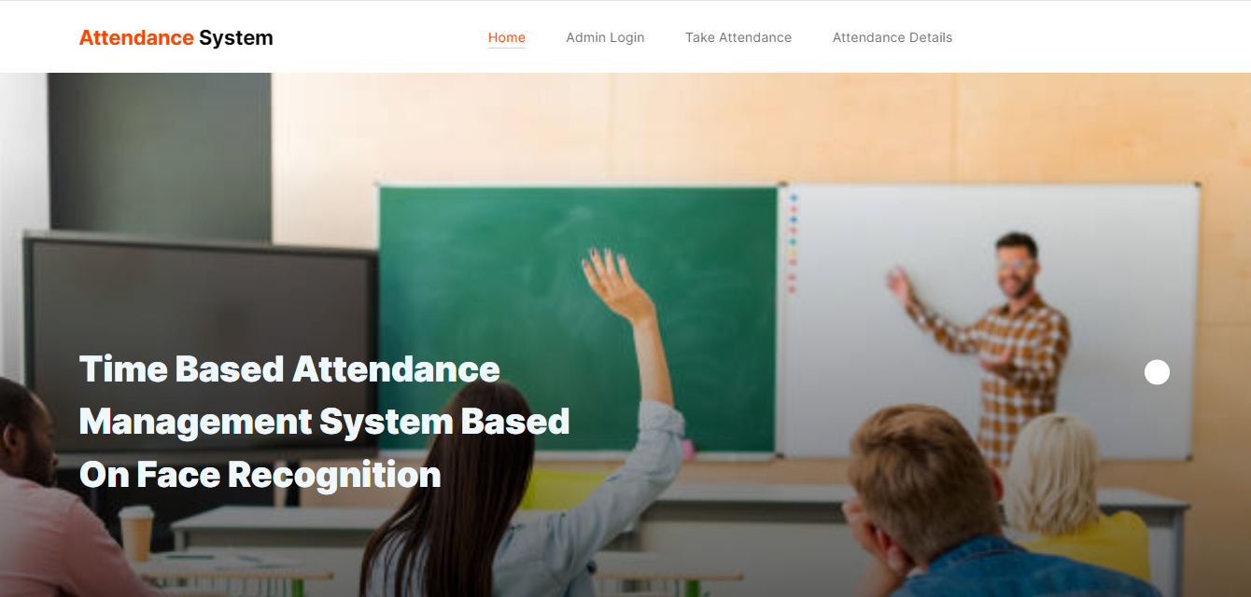

**Admin Login:** Admin will login with default creditionals line username and password.

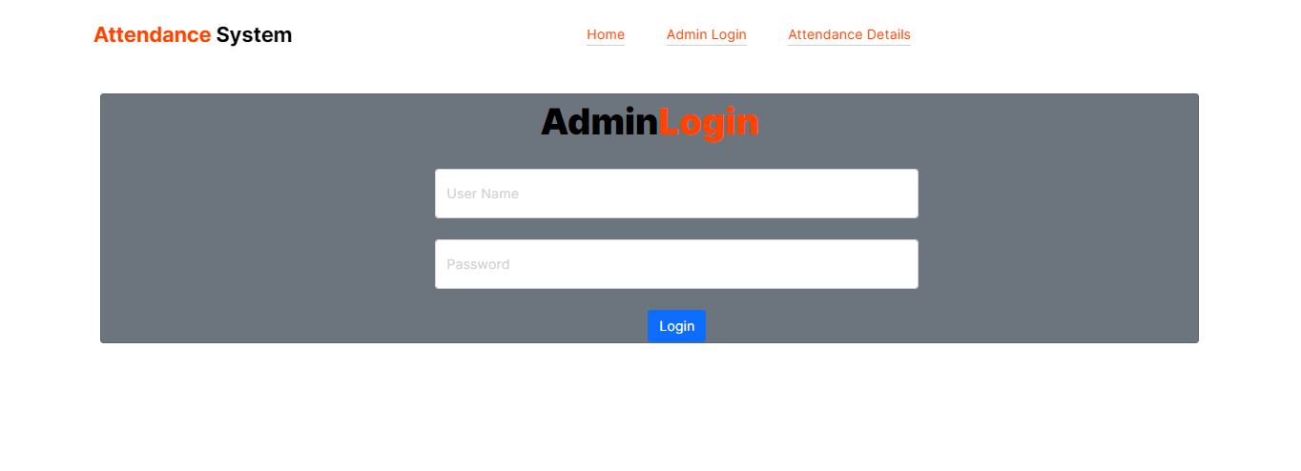

**Admin Home page:** After login the admin will enter into the home page.



**Upload Data:** Here the admin will add the students details here.

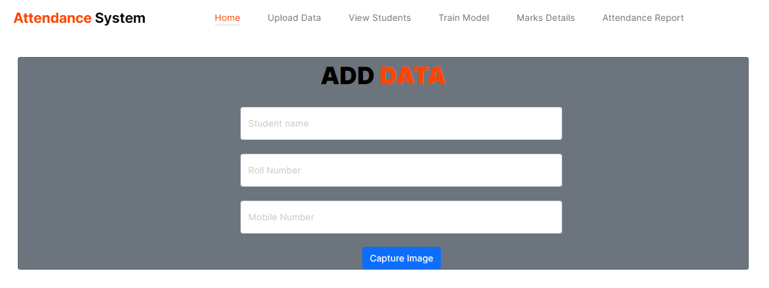

**Capture Image:**  Here it will capture the image for the student.

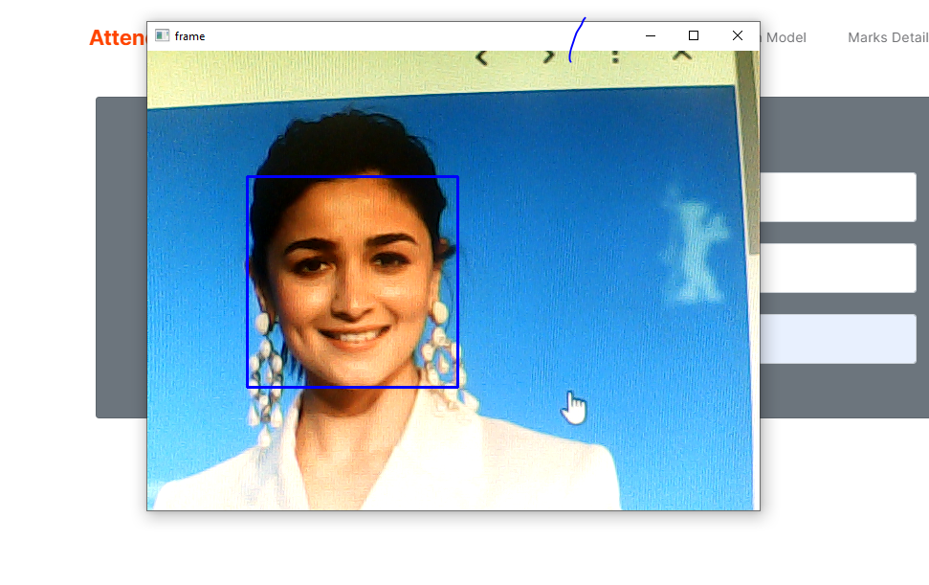

**View Students:** Here it will store the students details.

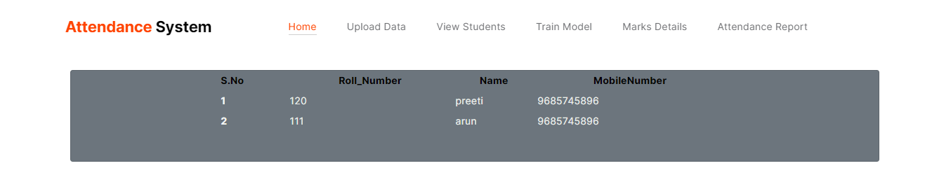

**Marks Details:**  The admin will add the students mid marks .

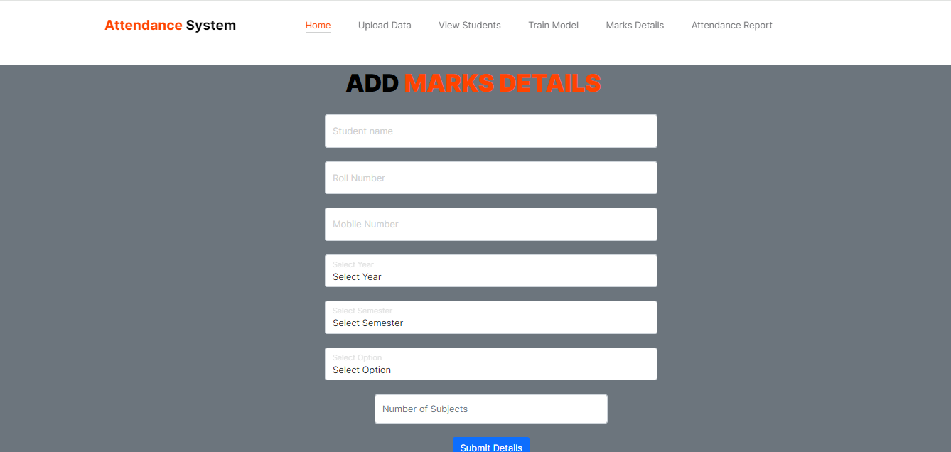

**Attendance report:**  Here the admin can view attendance report based on the date, month.

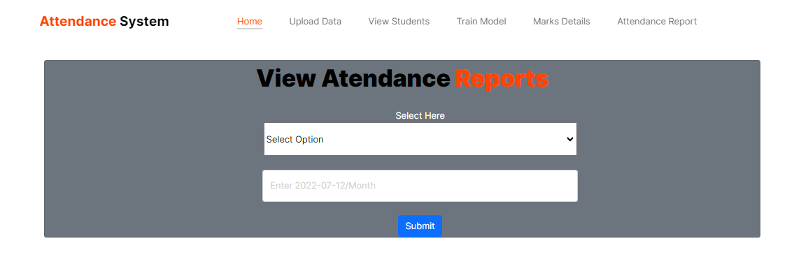

**View attendance report:**  Here the admin can view the attendance based on the date wise.

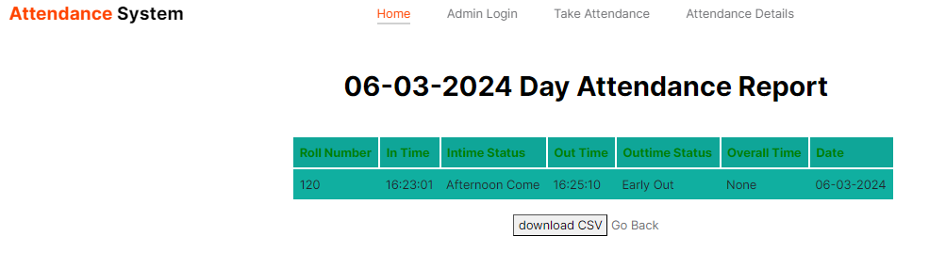

**View attendance:**

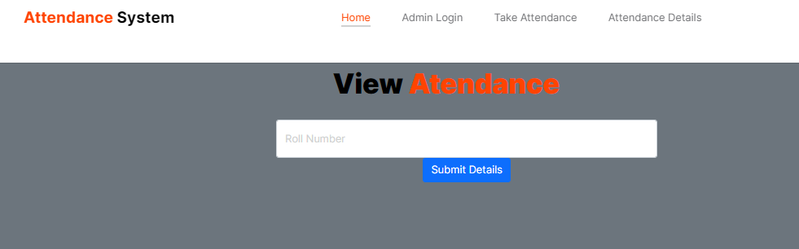

**View attendance report:**  Here students can view the attendance report.

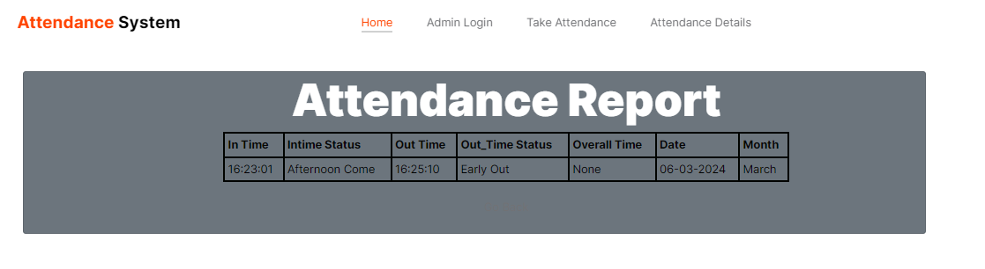

**8. SYSTEM STUDY AND TESTING**

The feasibility of the project is analysed in this phase and business proposal is put forth with a very general plan for the project and some cost estimates. During system analysis the feasibility study of the proposed system is to be carried out. This is to ensure that the proposed system is not a burden to the company. For feasibility analysis, some understanding of the major requirements for the system is essential.

Three key considerations involved in the feasibility analysis are

* Economical feasibility
* Technical feasibility
* Social feasibility

**Economical Feasibility**

This study is carried out to check the economic impact that the system will have on the organization. The amount of fund that the company can pour into the research and development of the system is limited. The expenditures must be justified. Thus the developed system as well within the budget and this was achieved because most of the technologies used are freely available. Only the customized products had to be purchased.

### Technical Feasibility

This study is carried out to check the technical feasibility, that is, the technical requirements of the system. Any system developed must not have a high demand on the available technical resources. This will lead to high demands on the available technical resources. This will lead to high demands being placed on the client. The developed system must have a modest requirement, as only minimal or null changes are required for implementing this system.

**Social Feasibility**

The aspect of study is to check the level of acceptance of the system by the user. This includes the process of training the user to use the system efficiently. The user must not feel threatened by the system, instead must accept it as a necessity. The level of acceptance by the users solely depends on the methods that are employed to educate the user about the system and to make him familiar with it. His level of confidence must be raised so that he is also able to make some constructive criticism, which is welcomed, as he is the final user of the system.

**System Testing**

The purpose of testing is to discover errors. Testing is the process of trying to discover every conceivable fault or weakness in a work product. It provides a way to check the functionality of components, sub-assemblies, assemblies and/or a finished product It is the process of exercising software with the intent of ensuring that the

Software system meets its requirements and user expectations and does not fail in an unacceptable manner. There are various types of test. Each test type addresses a specific testing requirement.

**8.2 Types of Tests**

**8.2.1 Unit testing**

Unit testing involves the design of test cases that validate that the internal program logic is functioning properly, and that program inputs produce valid outputs. All decision branches and internal code flow should be validated. It is the testing of individual software units of the application .it is done after the completion of an individual unit before integration. This is a structural testing, that relies on knowledge of its construction and is invasive. Unit tests perform basic tests at component level and test a specific business process, application, and/or system configuration. Unit tests ensure that each unique path of a business process performs accurately to the documented specifications and contains clearly defined inputs and expected results.

**8.2.2 Integration testing**

Integration tests are designed to test integrated software components to determine if they actually run as one program. Testing is event driven and is more concerned with the basic outcome of screens or fields. Integration tests demonstrate that although the components were individually satisfaction, as shown by successfully unit testing, the combination of components is correct and consistent. Integration testing is specifically aimed at exposing the problems that arise from the combination of components.

Software integration testing is the incremental integration testing of two or more integrated software components on a single platform to produce failures caused by interface defects.

The task of the integration test is to check that components or software applications, e.g. components in a software system or – one step up – software applications at the company level – interact without error.

**Test Results:** All the test cases mentioned above passed successfully. No defects encountered.

**Acceptance Testing**

User Acceptance Testing is a critical phase of any project and requires significant participation by the end user. It also ensures that the system meets the functional requirements.

**Test Results:** All the test cases mentioned above passed successfully. No defects encountered.

**8.2.3 Functional testing**

Functional tests provide systematic demonstrations that functions tested are available as specified by the business and technical requirements, system documentation, and user manuals.

Functional testing is centered on the following items:

Valid Input : identified classes of valid input must be accepted.

Invalid Input : identified classes of invalid input must be rejected.

Functions : identified functions must be exercised.

Output : identified classes of application outputs must be exercised.

Systems/Procedures: interfacing systems or procedures must be invoked.

Organization and preparation of functional tests is focused on requirements, key functions, or special test cases. In addition, systematic coverage pertaining to identify Business process flows; data fields, predefined processes, and successive processes must be considered for testing. Before functional testing is complete, additional tests are identified and the effective value of current tests is determined.

**9.2.4 White Box Testing**

White Box Testing is a testing in which in which the software tester has knowledge of the inner workings, structure and language of the software, or at least its purpose. It is purpose. It is used to test areas that cannot be reached from a black box level.

**9.2.5 Black Box Testing**

Black Box Testing is testing the software without any knowledge of the inner workings, structure or language of the module being tested. Black box tests, as most other kinds of tests, must be written from a definitive source document, such as specification or requirements document, such as specification or requirements document. It is a testing in which the software under test is treated, as a black box .you cannot “see” into it. The test provides inputs and responds to outputs without considering how the software works.

**Test objectives**

* All field entries must work properly.
* Pages must be activated from the identified link.
* The entry screen, messages and responses must not be delayed.

**Features to be tested**

* Verify that the entries are of the correct format
* No duplicate entries should be allowed
* All links should take the user to the correct page.
* **Test Results:** All the test cases mentioned above passed successfully. No defects encountered.

**TEST CASES:**

|  |  |  |
| --- | --- | --- |
| **Input** | **Output** | **Result** |
| Input image | Model recognize the face successfully | Success |

**Test cases Model building:**

|  |  |  |  |  |  |
| --- | --- | --- | --- | --- | --- |
| **S.NO** | **Test cases** | **I/O** | **Expected O/T** | **Actual O/T** | **P/F** |
| 1 | Login | Username and password | Login successfully | Login into the home page successfully | P |
| 2 | Login | Username and password | Login successfully | Username or password incorrect | F |
| 3 | Read the dataset. | Dataset path. | Dataset need to read successfully. | Dataset fetched successfully. | P |
| 4 | Performing pre-processing on the dataset | Pre-processing part takes place | Pre-processing should be performed on dataset | Pre-processing successfully completed. | P |
| 5 | Model Building | Model Building for the clean data | Need to create model using required algorithms | Model Created Successfully. | P |
| 6 | Face recognition | Video streaming  Or image upload | Face recognized successfully | Model recognize the face image and store the attendance data into database successfully | P |
| 7 | Face recognition | Video streaming  Or image upload | Face recognized successfully | Model does not identify the face properly at low quality data, that time system not consider the attendance | F |

**CONCLUSION**

In our proposed work, we have created a model that which can take the attendance of student in the allotted times by the face recognition if student not recognized I the allotted attendance taken time they will be given attendance as late coming. We have used Flask Framework, where the information about the student are stored and a model is trained and then the student picture is captured which is tested and attendance is taken to the student by the captured face image. And the whole process is hosting in AWS cloud for public service.

**FUTURE WORK**

In the future, we can extend the idea and can apply in different fields, like educational, corporate offices, and in many work places. That which can be easy to consider the attendance of a person with a lesser time.

**REFERENCES**

[1] Naveed Khan Balcoh, M. HaroonYousaf, Waqar Ahma and M. Iram Baig, Algorithm for efficient Attendance Management: Face Recognition Based approach, International Journal of Computer Science Issue, Vol.9, Issue 4, No 1, July 2012.

[2] NirmalayaKar, MrinalKanti Debbarma, Ashim Saha, and Dwijen RudraPal, Study of implementing Automated Attendance System using Implementing Automated Attendance System Using face recognition Technique, International Journal of Computer and Communication Engineering, Vol 1, No 2,July 2012

[3] O. Shoewn, Development of Attendance Management System using Biometrics. The Pacific Journal of Science and Technology Volume 13, No 1, May 2012

[4] M. Turk and A. Pentland (1991) “Face recognition using Eigen faces”. Proc.IEEE conference on computer vision and Pattern Recognition

[5] W.Zhao, R. Chellapa, P.J.Phillips and A.Rosenfld, “Face Recognition: A Literature Survey, vol. 35, No 4, Dec 2003, pp.399-458

[6] R.L. Hsu, Mottalec M.A and A.K.Jain,”Face Detection in colour images”, Proceedings International Conference on Image Processing, Oct 2001, pp. 1046-1049

[7] ToufiqP. Ahmed Egammal and Anurag mittal (2006),”A Framework for feature selection for Background Subtraction”, in Proceedings of IEEE computer Society Conference on Computer Vision and Pattern Recognition.

[8] M.H.Yang, N.Ahuja and D.Kriegmao, “Face recognition using kernel Eigen faces”, IEEE International Conference on Image Processing, vol.1, pp. 10-13, Sept. 2000

[9] Rekha A. L, Chethan H. K, “Automated Attendance System Management System Using Face Recognition through Video Surveillance”, Volume 1, Issue 11, July-2014

[10] Anil K. Jain, Arun Ross and Salil Prabhakar, “An introduction to biometric recognition”, Circuits and Systems for Video Technology, IEEE Transcations on Volume 14, Issu 1, Jan 2004 Page(s):4-20

[11] H. M. El Barkey, “Face detection using fast neural networks and image decomposition”, Neuro computing, Vol.11, no 3, pp 1039- 1046, 2002

[12] R. L. Hsu, Mottale M.A and A.K. Jain, “Face detection in colour images”, Proceedings International Conference on Image Processing (ICIP), Oct 2001, pp.1046-1049

[13] Prabhjot Singh and Anjana Sharma, “Face Recognition using Principal Component Analysis in MATLAB”, International Journal of Scientific Research in Computer Science and Engineering, vol.3,Issue 1, ISSN 2320-7639